Data Presentation and Visualization

3.2 Exercise -
1 scatterplot, 1 bubble chart and 1 density map using Python, R, Tableau

Week 5 & 6

Professor: Dr. Catherine Williams

Author: Karthikeyan Chellamuthu

Due Date: 07/17/2022

Python-Scatterplot

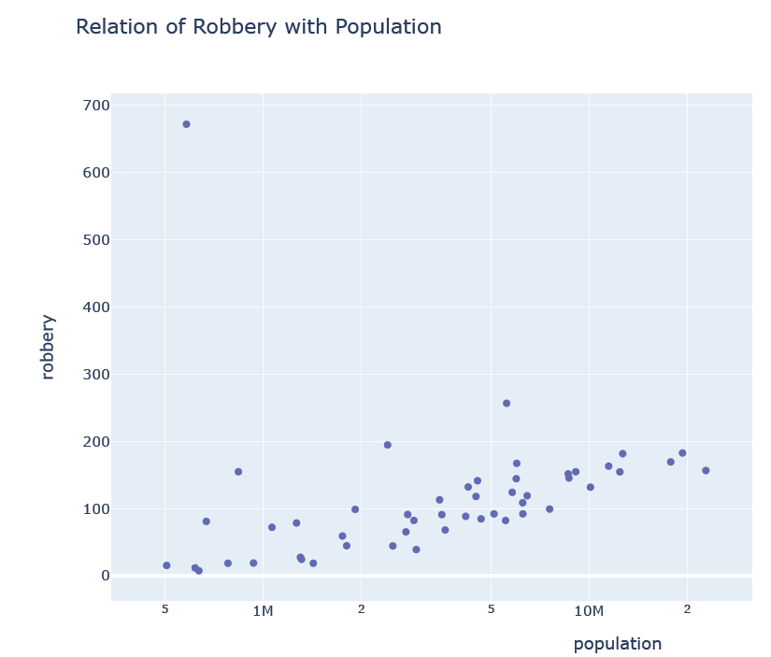

Python-Bubble Chart

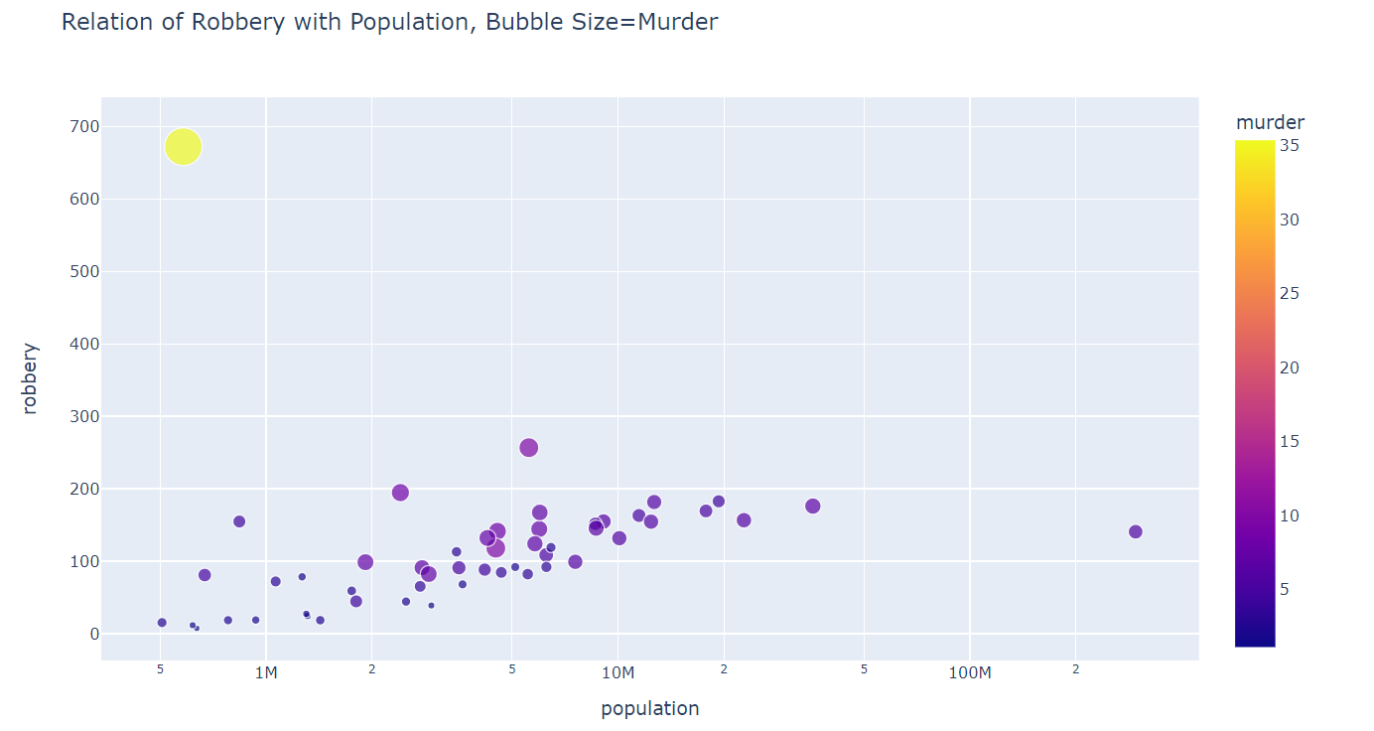

Python-Density chart

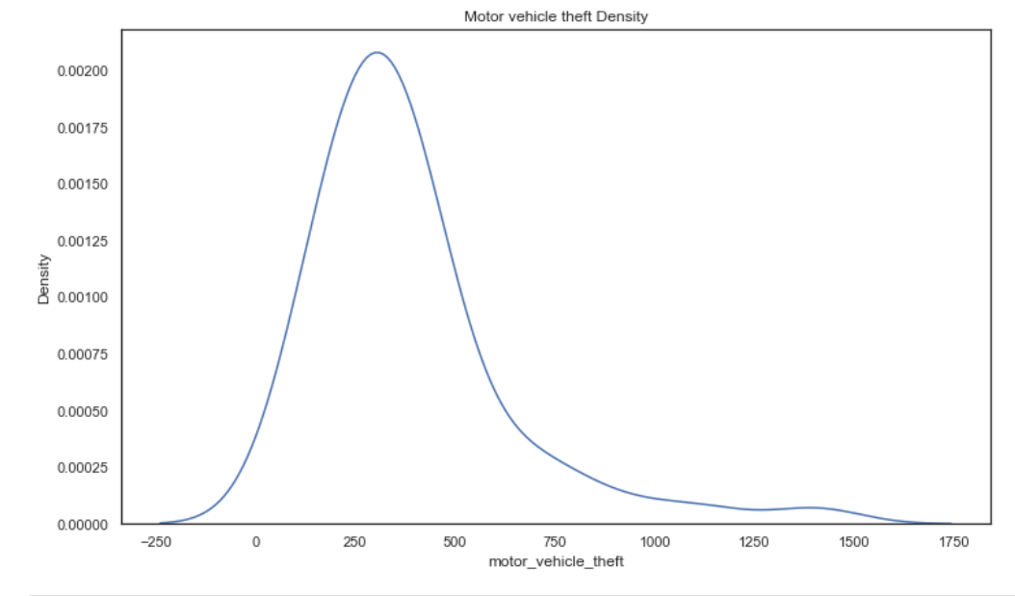

R-Scatterplot

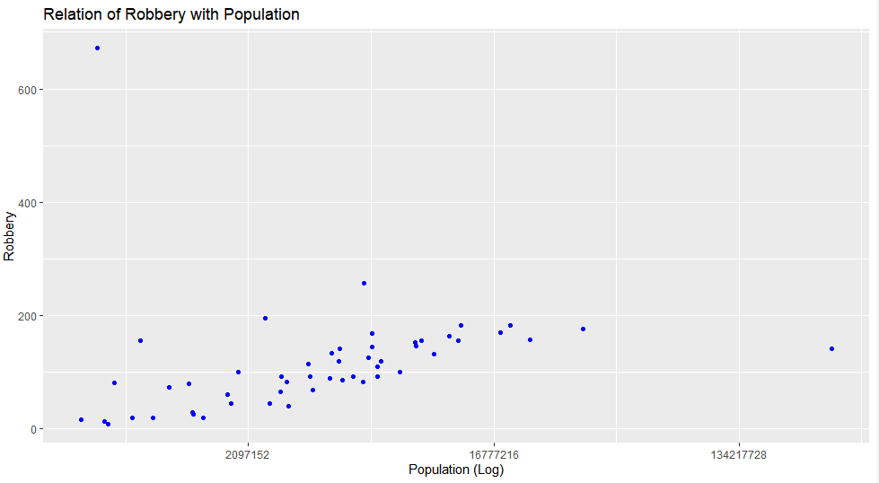

R-Bubble Chart

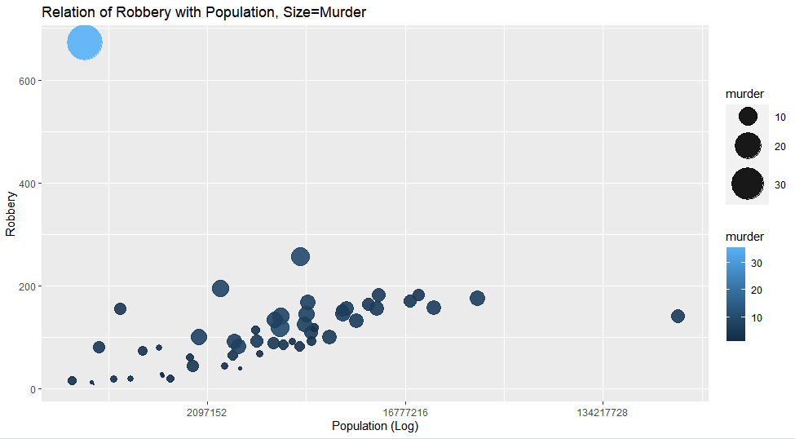

R-Density Map

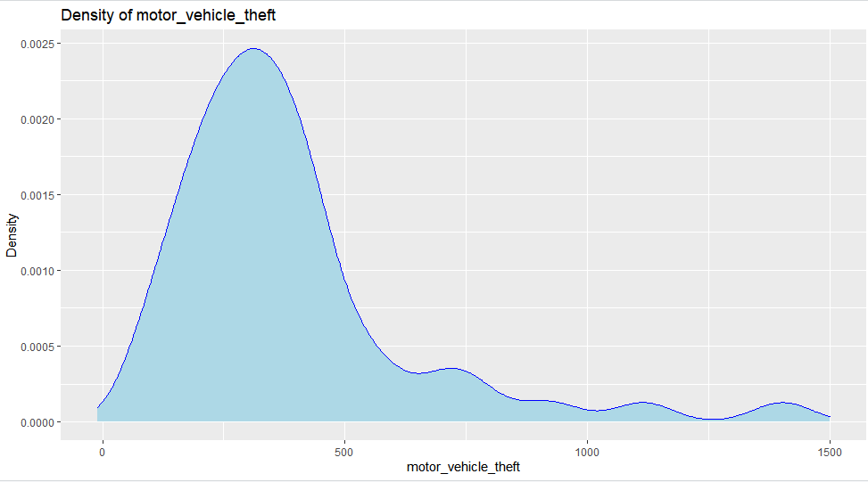

Tableau –Scatter plot

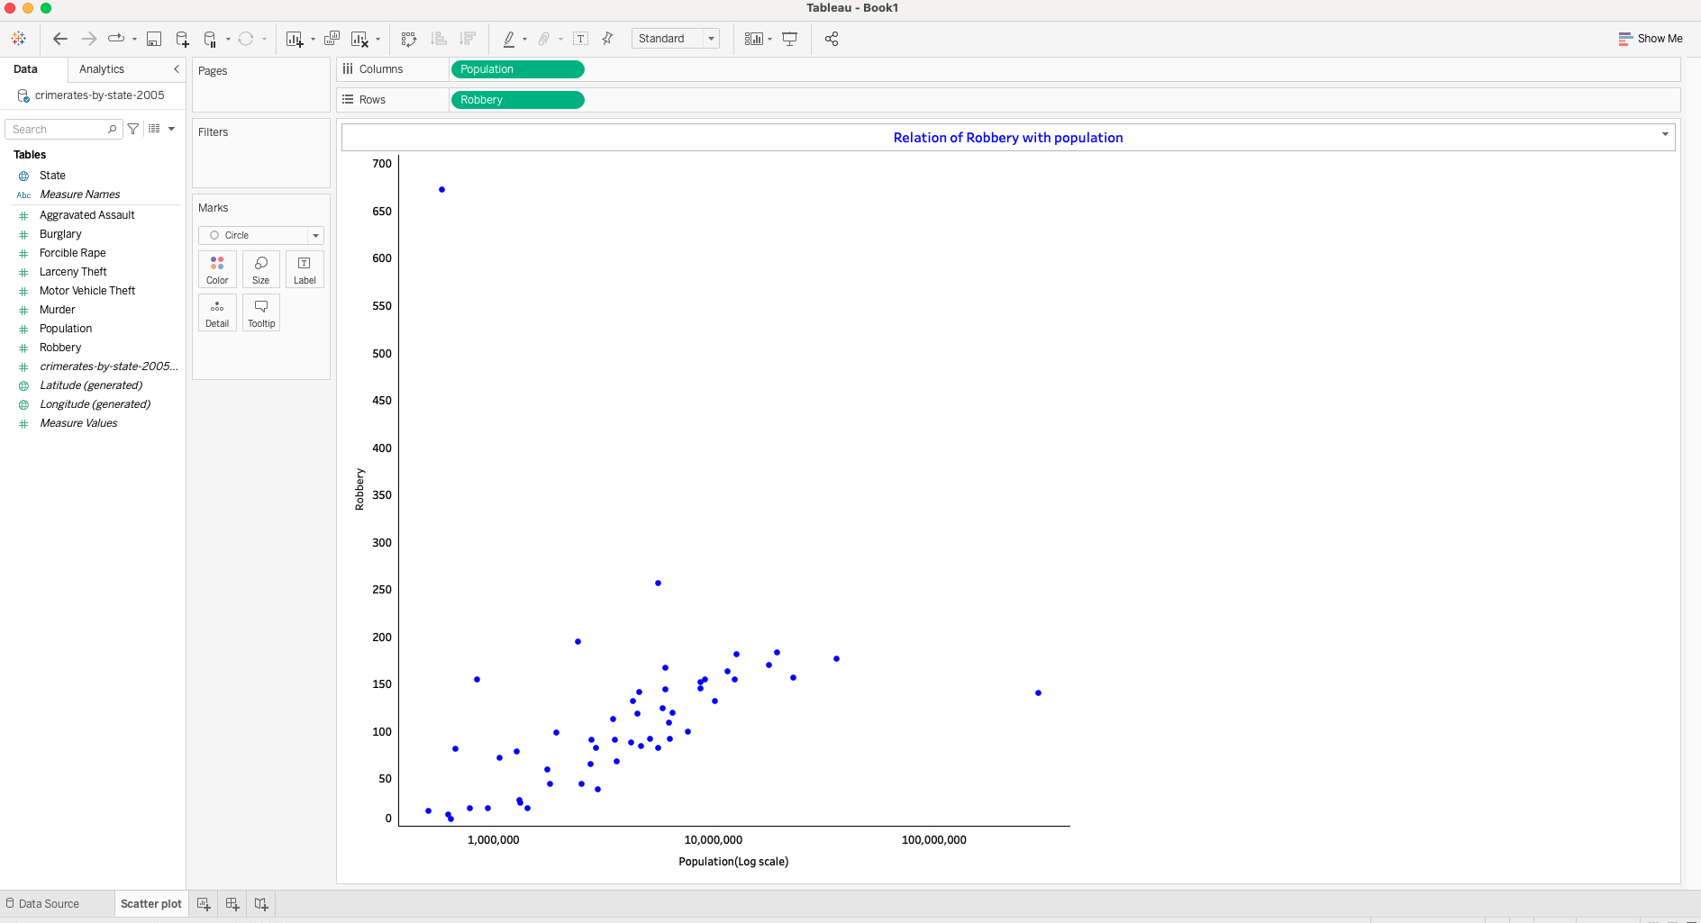

Tableau-Bubble Chart

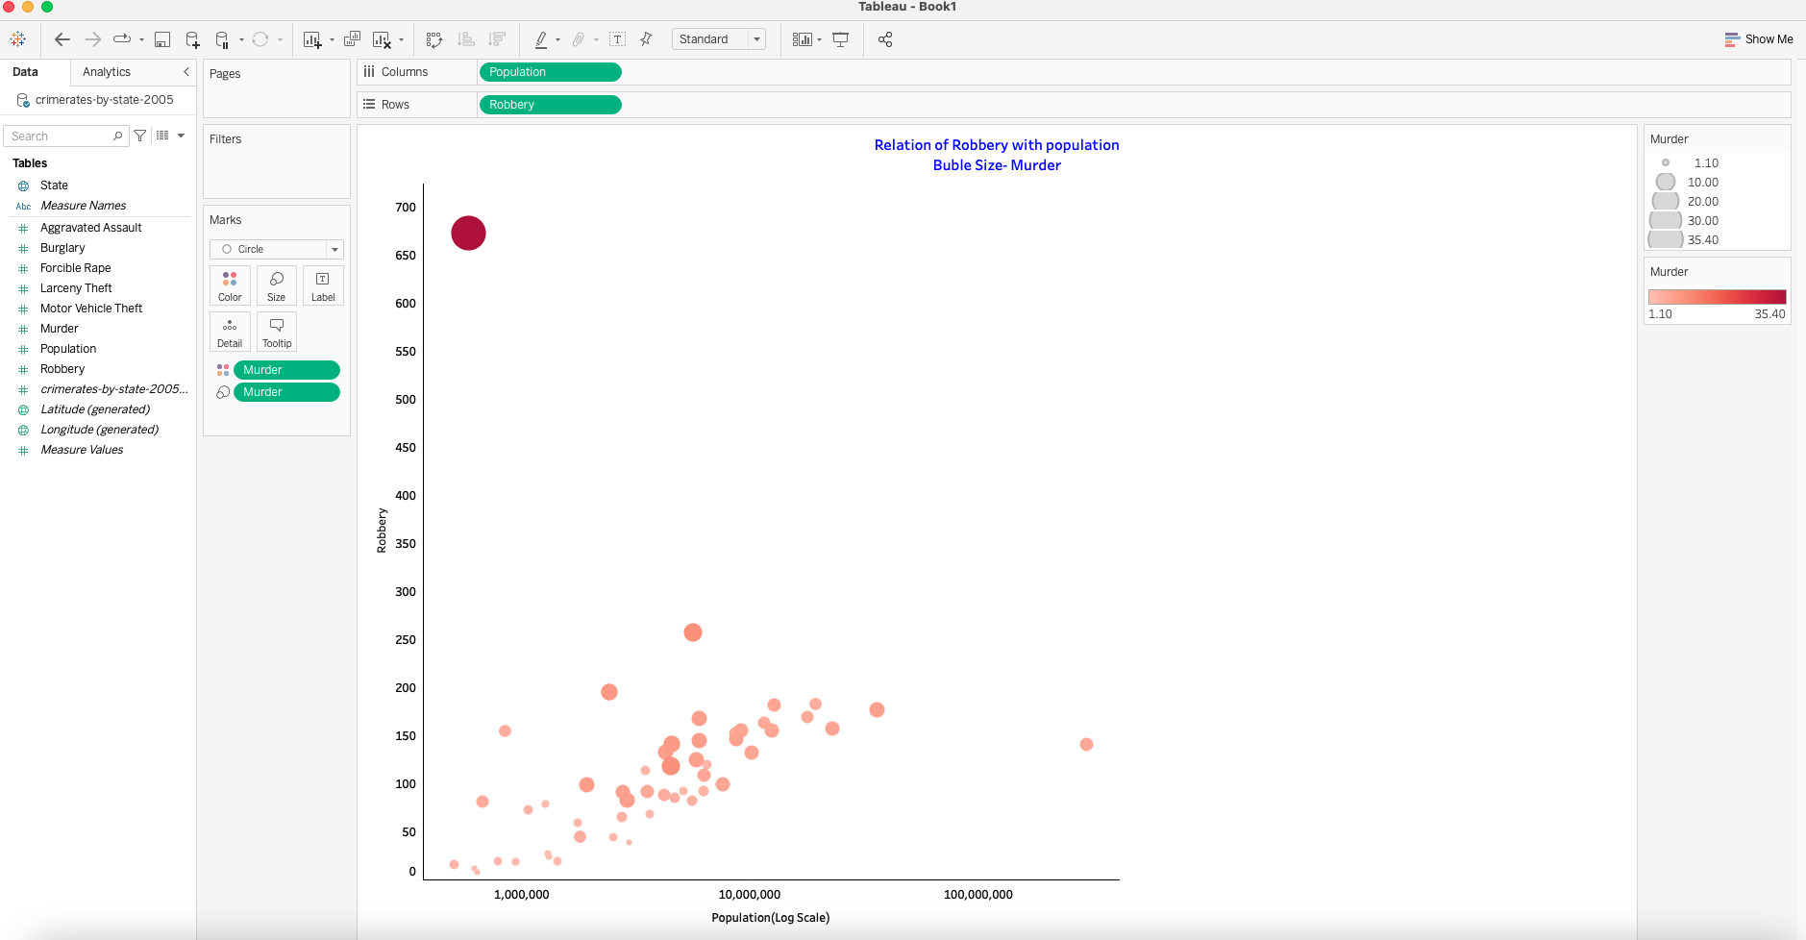

Tableau-Density
